**Analysis 3 Report**

**1.The memory usage of the data is around 53.9+ mb. How can we reduce the memory usage of the data set?**

we notice that we can reduce the memory usage by storing the data in more optimal types. For example, prices, kilometers and registration years are all positive values, we can use unsigned integers to store them instead of int64 and reduce the memory allocation.

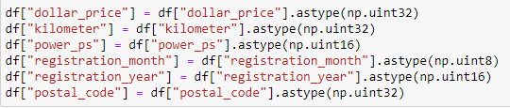

**2. What is the Average price of vehicle by fuel type and gearbox type. Give a plot.**

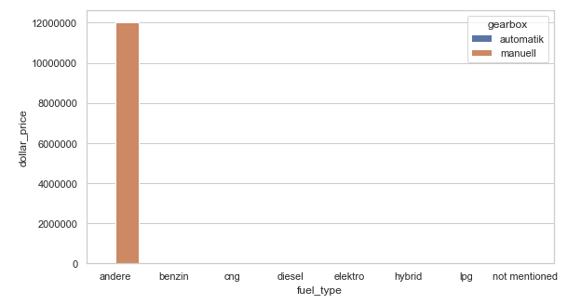

The vehicle with fuel type Andere and manual gear box type has the highest price on Ebay for sale.

**3.What is the Average power of a vehicle by vehicle type and gearbox type. Give a plot.**

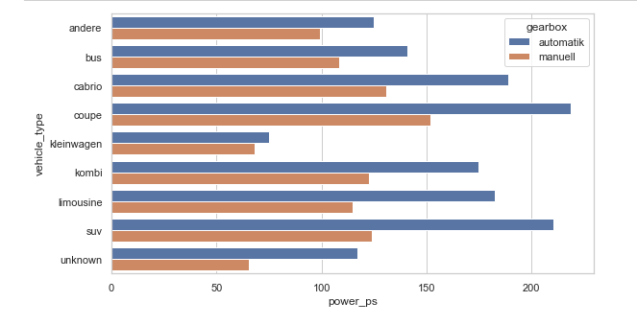

Vehicle type coupe with both automatic and manual has the high power compared to others and least is Klein Wagen has least power in both automatic and manual.

**4.What is the Average price of a vehicle by brand as well as vehicle type. Use heatmap to explain this.**

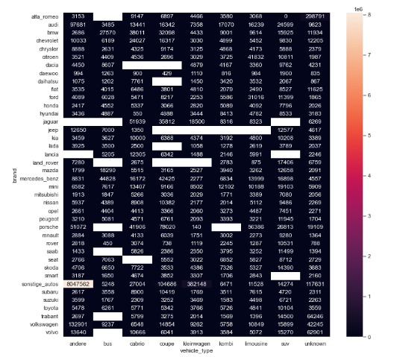

This plot in Andere vehicle type category, Audi appears to have the highest average price among the considered brands.

This visualization helps to identify which brands generally higher or lower prices within each vehicle type category. It offers a clear comparison of average prices across different brands and types